Use Case Name

**Driver Safety and Navigation Management App** : Tracks Driver Overspeeding and Auto-Reports the same by Generating an E-Challan.

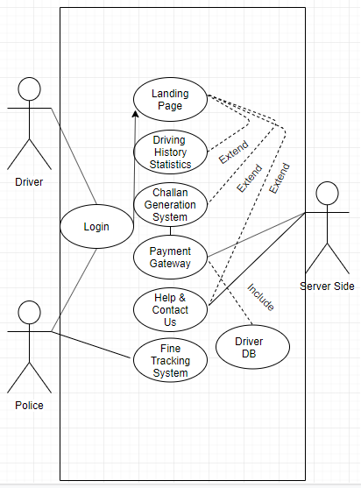

Actors:

Driver : Client Side, data collection using app

Police: Regulatory and invigilators authority

Server Side: Data computation and Challan Generation from data received from app

Precondition:

1. The client must have a proper browser to view the website
2. Stable internet connection
3. Valid means to pay off challans
4. Running app on phone to capture data

Event Flow:

1. User utilises the DSNM app while travelling
2. The application captures data and stored it in driver DB
3. Post travel, user accesses the web portal for DSNM to check if he has any dues
4. Valid Login required for the user
5. Challan Generation system generates challan for user and aggregates them in case there are multiple
6. User Proceeds to the payment gateway for paying the challans
7. Payment successful message displayed